ASSIGNMENT – 5
1. Student Marks Input Validation
import numpy as np

names = ['A','B','C,'D','E','F,'G',’H’,'I']
subjects = ['Math','Science','English']

marks_2d = np.array([ [85,80,88],[90,85,92],[78,72,75],[92,88,90],[67,70,65], [88,83,86],[74,78,80],[81,76,79],[95,91,93] ])

total = [marks_2d[i].sum() for i in range(len(names))]
[print(f'{n}: {t}') for n, t in zip(names, total)]

avg = [round(marks_2d[:, j].mean(), 2) for j in range(3)]
[print(f'{s}: {a}') for s, a in zip(subjects, avg)]

print(f'Top student: {names[np.argmax(total)]} ({max(total)} marks)')
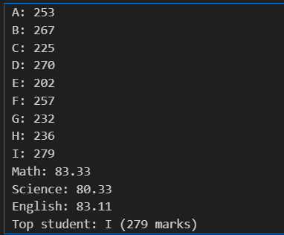

2. Data Filtering
import pandas as pd

df = pd.DataFrame({
'Name': ['A', 'B', 'C', 'D', 'E', 'F', 'G'],
'Marks': [85, 62, 91, 45, 78, 55, 88],
'City': ['City1', 'City2', 'City2', 'City3', 'City4', 'City5', 'City6']
})

above_70 = df[df['Marks'] > 70]

sorted_df = df.sort_values('Marks', ascending=False)

def assign_grade(m):
if m >= 90: return 'A+'
elif m >= 80: return 'A'
elif m >= 70: return 'B'
elif m >= 60: return 'C'
else: return 'D'

df['Grade'] = df['Marks'].apply(assign_grade)
print(df)

3. Student DataFrame
import pandas as pd

df = pd.DataFrame({
'Name': ['A', 'B', 'C', 'D', 'E', 'F', 'G'],
'Marks': [85, 62, 91, 45, 78, 55, 88],
'City': ['City1', 'City2', 'City2', 'City3', 'City4', 'City5', 'City6']
})

above_70 = df[df['Marks'] > 70]

sorted_df = df.sort_values('Marks', ascending=False)

def assign_grade(m):
if m >= 90: return 'A+'
elif m >= 80: return 'A'
elif m >= 70: return 'B'
elif m >= 60: return 'C'
else: return 'D'

df['Grade'] = df['Marks'].apply(assign_grade)
print(df)

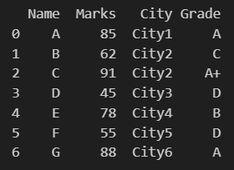
4. Employee Analysis
import pandas as pd

df_emp = pd.DataFrame({
'Name': ['A', 'B', 'C', 'D', 'E', 'F', 'G'],
'Department': ['IT', 'HR', 'IT', 'Finance', 'HR', 'Finance', 'IT'],
'Salary': [75000, 50000, 90000, 65000, 48000, 70000, 80000]
})

avg_sal = df_emp.groupby('Department')['Salary'].mean()

top = df_emp.loc[df_emp['Salary'].idxmax()]
print(f'Highest paid: {top["Name"]} - {top["Salary"]}')

count = df_emp.groupby('Department')['Name'].count()
print(count)
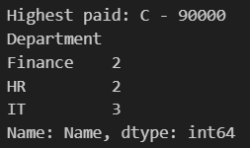

5. Missing Data Handling
import pandas as pd

df = pd.read_csv("data.csv")

print("Original Data:")
print(df)

print("\nMissing Values per Column:")
print(df.isnull().sum())

df_filled = df.fillna(df.mean(numeric_only=True))
print("\nData after filling missing values:")
print(df_filled)

df_dropped = df.dropna()
print("\nData after dropping missing rows:")
print(df_dropped)
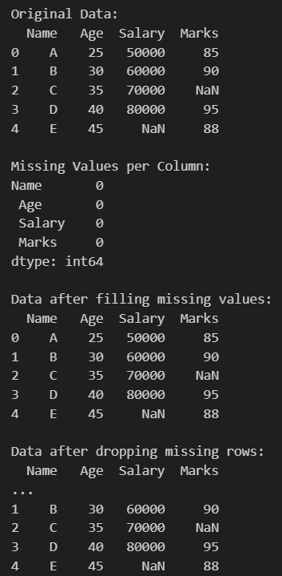

6. Load CSV & Basic Operations
import pandas as pd

df = pd.read_csv("data2.csv")
df.columns = df.columns.str.strip()

print("Top 5 Rows:")
print(df.head())

print("\nUnique Values in Category:")
print(df['Category'].unique())

print("\nGrouped Data (Category-wise Count):")
print(df.groupby('Category').size())
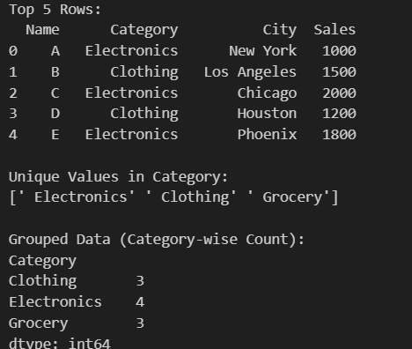

7. Data Aggregation
import pandas as pd

data = {
'Name': ['A', 'B', 'C', 'D', 'E', 'F', 'G'],
'City': ['Mumbai', 'Pune', 'Nagpur', 'Mumbai', 'Pune', 'Nagpur', 'Mumbai'],
'Salary': [75000, 55000, 45000, 85000, 60000, 48000, 90000],
'Age': [22, 24, 23, 25, 22, 26, 24]
}
df = pd.DataFrame(data)

result = df.groupby('City').agg({
'Salary': 'mean',
'Name': 'count'
})
result.rename(columns={'Salary': 'Average Income', 'Name': 'Total Population'}, inplace=True)
print(result)
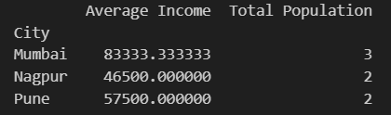

9. Merging DataFrames
import pandas as pd

students = {
'ID': [1, 2, 3, 4],
'Name': ['A', 'B', 'C', 'D']
}
df_students = pd.DataFrame(students)

marks = {
'ID': [1, 2, 3, 4],
'Marks': [88, 76, 91, 65]
}
df_marks = pd.DataFrame(marks)

merged = pd.merge(df_students, df_marks, on='ID')
print(merged)
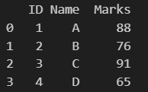

11. Product Comparison
import matplotlib.pyplot as plt

products = ['A', 'B', 'C', 'D', 'E']
sales = [120, 200, 150, 300, 250]

plt.bar(products, sales)
plt.title("Product Sales Comparison")
plt.xlabel("Products")
plt.ylabel("Sales")
plt.show()

max_sales = max(sales)
index = sales.index(max_sales)
print("Highest Selling Product:", products[index])
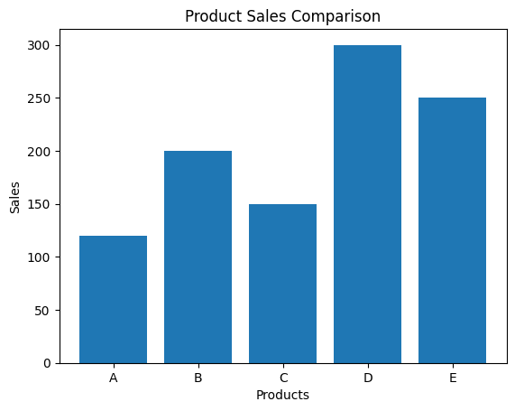
Highest Selling Product: D

12. Distribution Plot
import pandas as pd
import matplotlib.pyplot as plt

data = {
'Name': ['A', 'B', 'C', 'D', 'E', 'F', 'G'],
'City': ['Mumbai', 'Pune', 'Nagpur', 'Mumbai', 'Pune', 'Nagpur', 'Mumbai'],
'Salary': [75000, 55000, 45000, 85000, 60000, 48000, 90000],
'Age': [22, 24, 23, 25, 22, 26, 24],
'Marks': [88, 76, 91, 65, 73, 85, 90]
}
df = pd.DataFrame(data)

plt.hist(df['Marks'], bins=20)
plt.title("Distribution of Marks")
plt.xlabel("Marks")
plt.ylabel("Frequency")
plt.show()
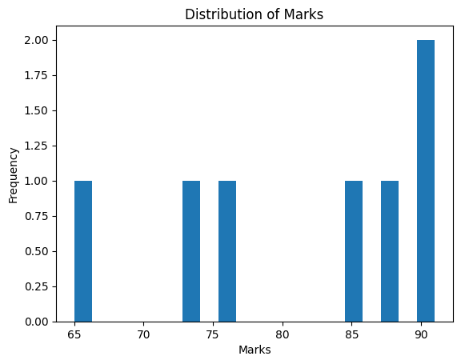

13. Multi-line Graph
import matplotlib.pyplot as plt

x = [1, 2, 3]
product1 = [10, 20, 30]
product2 = [15, 25, 35]

plt.plot(x, product1, label="Product 1")
plt.plot(x, product2, label="Product 2")
plt.legend()
plt.show()
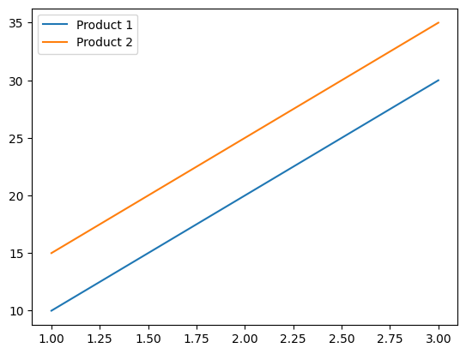

14. Heatmap
import seaborn as sns
import matplotlib.pyplot as plt
import pandas as pd

data = {
'Name': ['A', 'B', 'C', 'D', 'E', 'F', 'G'],
'City': ['Mumbai', 'Pune', 'Nagpur', 'Mumbai', 'Pune', 'Nagpur', 'Mumbai'],
'Salary': [75000, 55000, 45000, 85000, 60000, 48000, 90000],
'Age': [22, 24, 23, 25, 22, 26, 24],
'Marks': [88, 76, 91, 65, 73, 85, 90]
}
df = pd.DataFrame(data)

corr = df[['Salary', 'Age', 'Marks']].corr()
sns.heatmap(corr, annot=True)
plt.show()
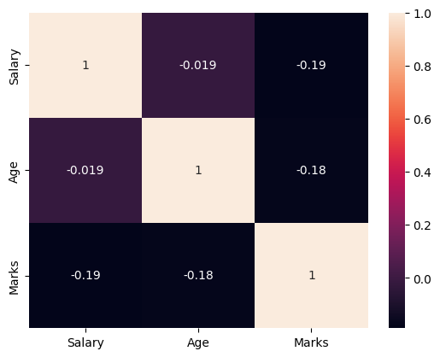

16. Pair Plot
import pandas as pd
import seaborn as sns
import matplotlib.pyplot as plt

data = {
'Name': ['A', 'B', 'C', 'D', 'E', 'F', 'G'],
'City': ['Mumbai', 'Pune', 'Nagpur', 'Mumbai', 'Pune', 'Nagpur', 'Mumbai'],
'Salary': [75000, 55000, 45000, 85000, 60000, 48000, 90000],
'Age': [22, 24, 23, 25, 22, 26, 24],
'Marks': [88, 76, 91, 65, 73, 85, 90]
}
df = pd.DataFrame(data)

sns.pairplot(df)
plt.show()
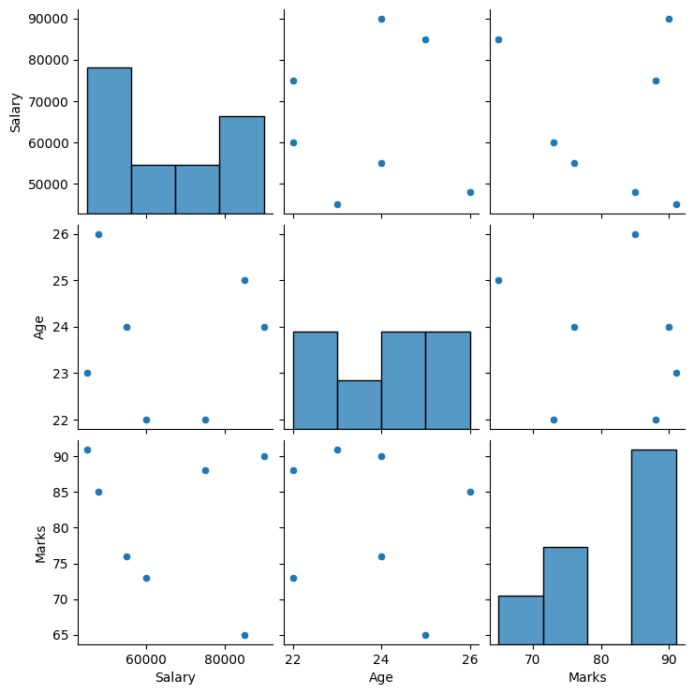

17. Count Plot
import pandas as pd
import seaborn as sns
import matplotlib.pyplot as plt

data = {
'Name': ['A', 'B', 'C', 'D', 'E', 'F', 'G'],
'City': ['Mumbai', 'Pune', 'Nagpur', 'Mumbai', 'Pune', 'Nagpur', 'Mumbai'],
'Salary': [75000, 55000, 45000, 85000, 60000, 48000, 90000],
'Age': [22, 24, 23, 25, 22, 26, 24],
'Marks': [88, 76, 91, 65, 73, 85, 90]
}
df = pd.DataFrame(data)

sns.countplot(x='City', data=df)
plt.title("Number of Students per City")
plt.xlabel("City")
plt.ylabel("Count")
plt.show()
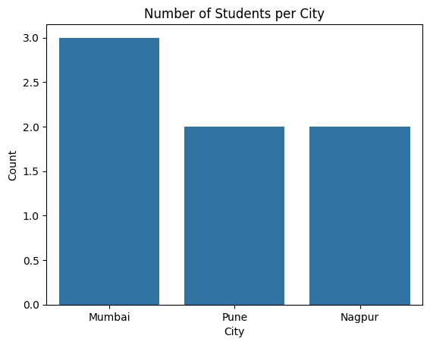
1. Student Management System (CRUD)
import mysql.connector

conn = mysql.connector.connect(host="localhost", user="root", password="brucewayne")
cursor = conn.cursor()

cursor.execute("CREATE DATABASE IF NOT EXISTS student_db")
cursor.execute("USE student_db")

cursor.execute("""
CREATE TABLE IF NOT EXISTS students (
id INT AUTO_INCREMENT PRIMARY KEY,
name VARCHAR(100),
age INT,
course VARCHAR(100)
)
""")

students_data = [
('A', 22, 'Data Science'),
('B', 24, 'Python'),
('C', 23, 'AI'),
('D', 25, 'ML'),
('E', 22, 'SQL')
]

cursor.executemany("INSERT INTO students (name, age, course) VALUES (%s, %s, %s)", students_data)
conn.commit()

print("All Students:")
cursor.execute("SELECT * FROM students")
for row in cursor.fetchall():
print(row)

cursor.execute("UPDATE students SET course='Deep Learning' WHERE name='B'")
conn.commit()

cursor.execute("DELETE FROM students WHERE id=3")
conn.commit()

name = 'A'
cursor.execute("SELECT * FROM students WHERE name=%s", (name,))
print("\nSearch Result:")
print(cursor.fetchall())

cursor.close()
conn.close()
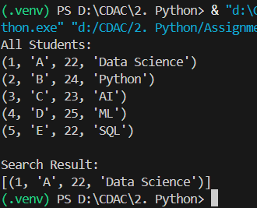
2. Employee Database
import mysql.connector

conn = mysql.connector.connect(host="localhost", user="root", password="brucewayne")
cursor = conn.cursor()

cursor.execute("CREATE DATABASE IF NOT EXISTS company_db")
cursor.execute("USE company_db")

cursor.execute("""
CREATE TABLE IF NOT EXISTS employee (
emp_id INT AUTO_INCREMENT PRIMARY KEY,
name VARCHAR(100),
department VARCHAR(100),
salary FLOAT
)
""")
conn.commit()

while True:
print("\n--- Employee Menu ---")
print("1. Add Employee")
print("2. View All Employees")
print("3. Update Salary")
print("4. Delete Employee")
print("5. Highest Paid Employee")
print("6. Count Employees per Department")
print("7. Exit")

choice = int(input("Enter choice: "))

if choice == 1:
name = input("Enter name: ")
dept = input("Enter department: ")
salary = float(input("Enter salary: "))
cursor.execute("INSERT INTO employee (name, department, salary) VALUES (%s, %s, %s)", (name, dept, salary))
conn.commit()
print("Employee added successfully!")

elif choice == 2:
cursor.execute("SELECT * FROM employee")
for row in cursor.fetchall():
print(row)

elif choice == 3:
emp_id = int(input("Enter employee ID: "))
new_salary = float(input("Enter new salary: "))
cursor.execute("UPDATE employee SET salary=%s WHERE emp_id=%s", (new_salary, emp_id))
conn.commit()
print("Salary updated!")

elif choice == 4:
emp_id = int(input("Enter employee ID to delete: "))
cursor.execute("DELETE FROM employee WHERE emp_id=%s", (emp_id,))
conn.commit()
print("Employee deleted!")

elif choice == 5:
cursor.execute("SELECT * FROM employee ORDER BY salary DESC LIMIT 1")
print("Highest Paid Employee:")
print(cursor.fetchone())

elif choice == 6:
cursor.execute("SELECT department, COUNT(*) FROM employee GROUP BY department")
print("Employees per Department:")
for row in cursor.fetchall():
print(row)

elif choice == 7:
print("Exiting program...")
break

else:
print("Invalid choice!")

cursor.close()
conn.close()

